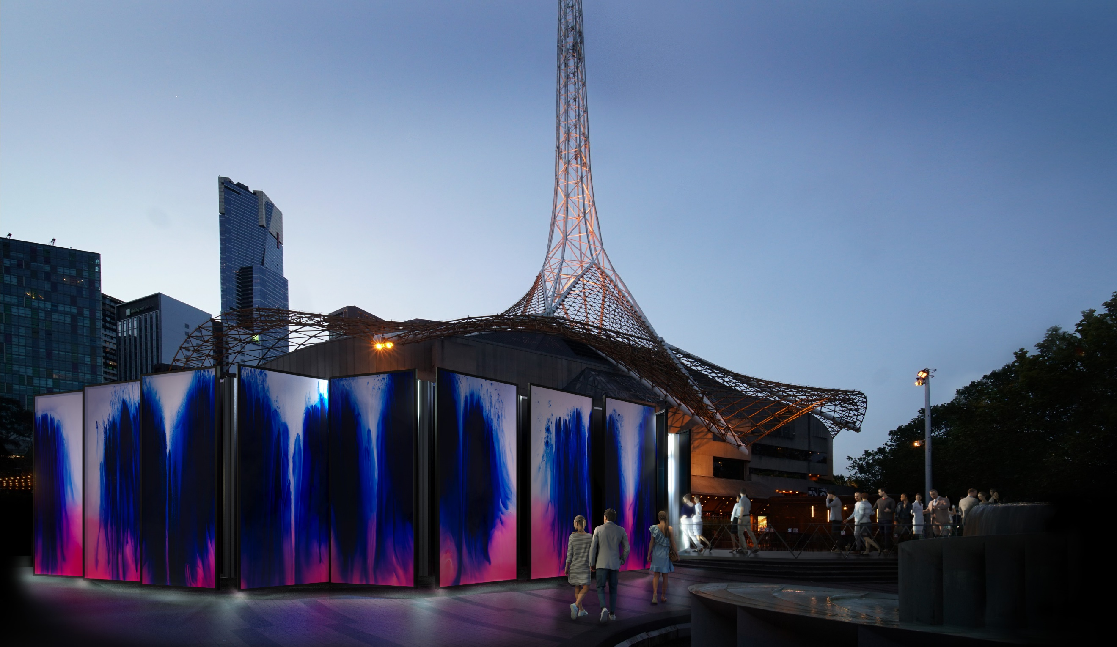

Presented by Arts Centre Melbourne in association with RISING
KALEIDOSCOPE
By Keith Courtney
1 June – 24 July
Kaleidoscope takes you inside a giant version of a toy you might have played with, a cylinder of colour and mirrors. Artist Keith Courtney has created a large space that you can step inside to discover a mirror maze. People can walk through the structure to explore surprising, new and different spaces. Once inside you will see coloured light revolving against corridors and rooms made of mirrors, and you will hear children in a choir singing. While you are inside Kaleidoscope, the experience might feel confusing at times, but it could also feel like a calm dream or a curious journey.

What To Expect and Content Warnings
- The experience begins when you arrive at Arts Centre Melbourne on St Kilda Road. You’ll discover Kaleidoscope outside the Theatres Building, which has a large spire on top. Kaleidoscope is the temporary structure with high walls that is installed on the Forecourt. The outside of this structure has been painted in colour by artist Ash Keating. The walls hide a mysterious space that you can explore.
- Also on the Forecourt is the outdoor café Protagonist, a temporary food truck called Lobster & Co, and the box office booth selling tickets available on the day you attend Kaleidoscope.

- Staff members wearing black uniforms and coloured lanyards, called ushers, will be able to help you with directions, enter the Kaleidoscope space, and answer any questions you have about the event or Arts Centre Melbourne, such as where to find the accessible toilets on Level 6 of the Theatres Building.
- There is one entrance to Kaleidoscope, and one exit. To get inside, you can push a big, black door. To get back out, you can push a big, mirrored door, but it will be hard to find. If you need to take a break, you are welcome to leave and return to the space when you are ready – trained staff are available to help as needed.
- Visitors are invited to journey through the Kaleidoscope structure, which is open to the air without an actual ceiling, so you can see the sky.
- Inside Kaleidoscope, you’ll find walls made of mirrors, forming many pathways. It becomes a maze, where every turn you take leads to a new room or corridor. It’s best to take your time to explore without rushing or running.
- Different coloured lights will reflect and revolve in patterns through the mirrors, forming an optical illusion that tricks the eye, making you wonder what is real and what is not. Sometimes the entire space is emptied of colour and lit up with white. There is no strobe lighting, and no fast, flashing light changes.
- While you are in Kaleidoscope, the music of children singing in a choir fills the air. The pitch of the voices can be high, and the volume can get loud, so you might want to wear headphones or ear plugs.
- The journey through this maze can be strange and confusing, so you might feel trapped, lost, or dizzy. If you need help finding your way out, remember you can ask the ushers for directions.
Important To Note
The experience of Kaleidoscope can change with the weather and time of day. When it is sunny, the mirrors can reflect a strong light, so you might want to wear sunglasses. When it is wet and rainy, it is still safe to move through the space, just be careful. At night the coloured lights are more visible, and it can be more difficult to find your way through the maze.

Low Sensory Session

For anyone who would benefit from a more relaxed environment, a Low Sensory Session will take place on Saturday, 2 July, from 11:00am to 12:00pm.

This session will have minor changes to the experience such as lowering the soundscape volume, and ear plugs will be available upon request. There will be more ushers available to help visitors, and fewer visitors moving through the space than at other times. During the session you can stay for a short time or for as long as 30 minutes.

Age Recommendation

People of all ages are welcome to explore Kaleidoscope. Children 5 years and under, and people 75 years and over, are admitted for free. Children participating in Kaleidoscope must be supervised by their teacher or guardian at all times.

Access Information

Wheelchair Access

The Kaleidoscope space is accessible for wheelchair users, with a pathway width of 1.8m
Companion Card

